TEST CASE 1

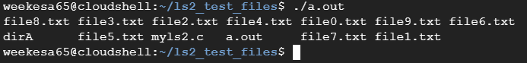

TEST CASE 2



TEST CASE 3



TEST CASE 4



